Final project report, AI Engineering (IC00BD87-3001)

Hoan Le Hoan.Le@student.oulu.fi Student number: 2504960
Khoa Dinh t0dida00@students.oamk.fi Student number: 2508783
Van Nguyen Van.M.Nguyen@student.oulu.fi Student number: 2506205

1. Project name: CodeSentinel – AI-assistant Code Review Tools

2. Provide instructions on how to run the project

To run the project, first install the required Python packages: pip install -r requirements.txt
Then start the web application: python app.py
Open your browser and go to: http://localhost:5000
You can also run the command-line version:
- Single file: python main.py --file path/to/your_code.py
- Paste inline: python main.py –inline
- Entire project: python main.py --project path/to/your_project/

3. System purpose/primary goal:
CodeSentinel is a multi-agent system that performs automated code review on source code written in any programming language. It accepts input as a pasted snippet, a single source file, or an entire project directory — via a web browser UI or a command-line interface. The system detects the programming language automatically, routes code through three specialist review agents, and presents the findings as a structured, colour-coded report.

The primary goal is to help developers and students quickly identify bugs, style violations, and security issues across a wide range of languages and input types — without needing language-specific configuration, tool setup, or command-line experience.

4. System boundaries (in scope/out of scope) and non-goals
In Scope
- Code review for any programming language the underlying LLM has knowledge of
- Three input modes: inline snippet, single file upload, project directory path
- Real-time agent progress display in the browser via Server-Sent Events
- Bug detection, style analysis, and security auditing per file
- Automatic language detection from file extension and/or LLM inference
- Manual language override via dropdown in the UI
- Project-level combined report with per-file sections and an overall verdict
- Colour-coded verdict badge (PASS / PASS WITH NOTES / NEEDS REVISION)
- Downloadable markdown report
- CLI interface for non-browser use
- Multi-agent orchestration using AG2 GroupChat
Out of Scope
- Languages the LLM has no training knowledge of (review quality not guaranteed)
- Automatic code fixing or patching
- User accounts, authentication, or saved review history
- Deployment to a public server (designed for localhost use)
- Integration with GitHub, GitLab, or CI/CD pipelines
- Projects larger than 20 files (capped with a warning)
- Files larger than 100 KB (skipped as likely generated or minified)
- Runtime execution of submitted code
Non-Goals
- The system should not execute or run user-provided code under any circumstances
- The system should not make architectural design recommendations
- The system should not rewrite or auto-correct code on behalf of the user

5. Top-level tasks the system must accomplish
- Serve a web UI at localhost:5000 with three input tabs (Inline, File, Project)
- Accept code input via UI or CLI and resolve it to one or more (filepath, content, language) tuples
- For project mode: scan the directory, skip non-code and oversized files, cap at 20 files
- Detect programming language from file extension hint and LLM inference; allow manual override
- Stream real-time agent progress to the browser via Server-Sent Events
- Bug Detector Agent: Identify bugs using language-appropriate best practices
- Style Checker Agent: Flag violations of the relevant style guide for the detected language
- Security Auditor Agent: Identify OWASP-relevant vulnerabilities with HIGH/MEDIUM/LOW labels
- Summarizer Agent: Aggregate findings, produce a structured report, call save_review_to_file
- Return the rendered report to the browser with a colour-coded verdict badge
- Save the final report to review_output.md and offer it as a download

6. Is there a human in the loop?
Yes — Human interaction via the UI.
The human provides the input (code snippet, file upload, or folder path) through the browser interface and can optionally override the detected language. Once the review is submitted, the system runs fully automatically. The human reads the rendered report and acts on the findings. There is no approval or intervention step within the agent pipeline itself.

7. Success criteria
Test Scenario | Input Mode | Expected Outcome
Python snippet with eval() and PEP 8 errors | UI — Inline | All issues detected, report rendered in browser
JavaScript file with innerHTML injection | UI — File upload | Security finding with HIGH severity, red verdict badge
Java file with SQL concatenation bug | UI — File upload | Bug + security findings, NEEDS REVISION verdict
Go file with clean idiomatic code | CLI — file | No critical issues, PASS verdict
Mixed project (py + js + java files) | UI — Project path | Per-file sections, combined verdict, downloadable report

Metric | Measurement | Target
UI loads correctly | Browser renders all three tabs without errors | 100%
Language detection accuracy | Correct language / total inputs | ≥ 95% for common languages
SSE progress updates | All 5 steps shown correctly during review | 100%
Bug detection rate | % of planted bugs correctly found | ≥ 70%
Style detection rate | % of style violations flagged | ≥ 70%
Security detection rate | % of known vulnerabilities found | ≥ 70%
False positive rate | Findings flagged that are not real issues | ≤ 2 per file
Report rendered correctly | Markdown renders without broken layout | 100%
Download works | review_output.md downloads with correct content | 100%
Report quality | Human rating (1–5) for clarity and usefulness | ≥ 4/5

8. If your system uses external data, list and briefly describe it here.
- None. The system uses only the code provided at runtime as input.
- The LLMs accessed via OpenRouter through the AWS proxy serve as the knowledge base for language-specific conventions, style guides, and vulnerability patterns.
- marked.js (loaded from CDN) is used client-side to render markdown — no data is sent to it.

9 . Name the multi-orchestration pattern used in your system
AG2 GroupChat with Custom Speaker Selection Function (Orchestrator Pattern)
The system uses AG2's GroupChat with a custom speaker_selection_func to enforce a strict agent execution order. When a review is submitted (via UI or CLI):
- The UserProxy agent initiates the group chat with the code snippet and detected language.
- The Bug Detector, Style Checker, and Security Auditor agents speak in sequence.
- The custom speaker selection function ensures Summarizer only speaks after all three.
- The Summarizer calls save_review_to_file, saves the report, outputs REVIEW COMPLETE.
For project mode, specialist agents loop over each file; Summarizer runs once at the end.
The Flask UI runs the agent GroupChat in a background thread so the browser stays responsive. A shared queue.Queue passes progress events from the agent thread to the SSE endpoint, which streams them to the browser.

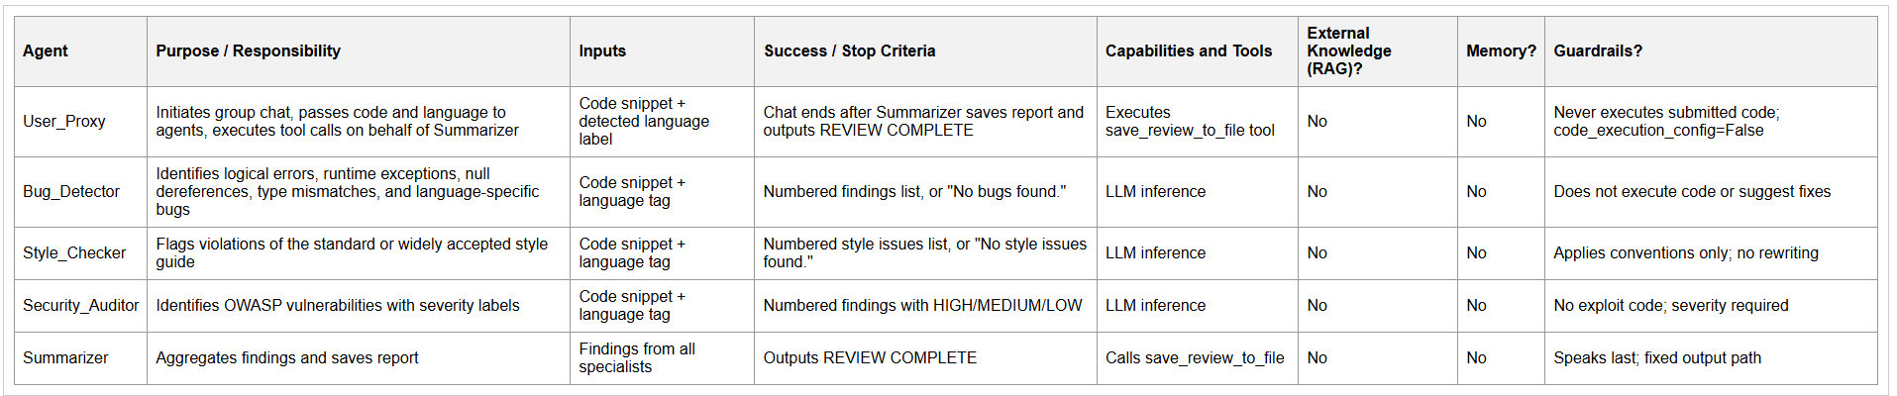

10. Justify your choice of multi-agent orchestration pattern
AG2's GroupChat with a custom speaker selection function was chosen for the following reasons:

1. Strict ordering without manual chaining. The custom speaker_selection_func enforces that the Summarizer speaks only after all three specialists have contributed, cleanly and without hardcoded chaining logic.

2. Separation of concerns. Each specialist focuses on one review dimension. This reduces prompt complexity and produces higher-quality, more focused outputs than a single "do everything" agent.

3. Language-agnostic prompting. Each agent receives the detected language as context and applies the LLM's own knowledge of that language's best practices. The same agents handle Python, Go, Rust, and any other language without maintaining hardcoded rule tables.

4. Background thread compatibility. Because AG2's GroupChat is self-contained and returns after REVIEW COMPLETE, it runs cleanly in a Flask background thread. Progress events are emitted to a shared queue without modifying the agent architecture.

5. Natural scalability to project mode. Stateless specialist agents loop over files with no redesign; only the Summarizer's input changes for project reviews.

6. Tool call integration. Assigning save_review_to_file to the Summarizer (with UserProxy as executor) is idiomatic AG2 and satisfies the assignment's tool call requirement in a motivated way — saving the report is the natural final step.

A reflection or debate pattern was considered but rejected — code review sub-tasks are independent and do not require agents to critique each other's output.

11. What are the safety/security concerns in your system, and how did you address them?

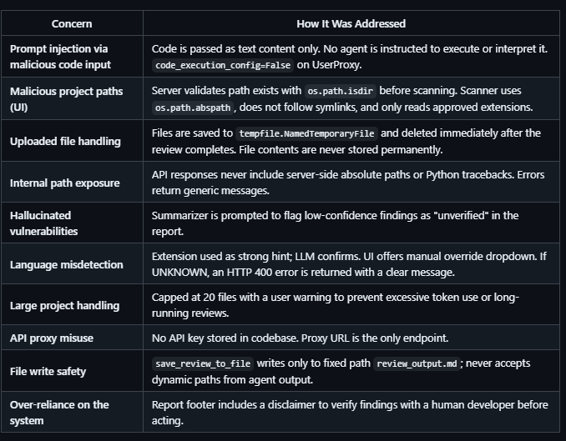

Declaration of use of AI
- Code: GitHub Copilot was used for boilerplate and autocomplete. Claude (claude.ai) was used to generate initial agent system prompt templates, the Flask route structure, and the CLAUDE.md project instruction file — all manually reviewed and refined.
- Report: This report was drafted with assistance from Claude (claude.ai) based on project description, architecture decisions. All content was reviewed and edited by the students.

